Exercise No 1  
 Image Maps

Question : 2

Create clickable areas for three animals in the picture. When you click the animal,  
features about the animal have to be displayed in another web page.

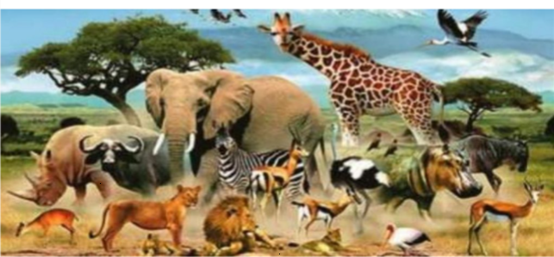

Initial code:

<html>

<head>

<title> My page </title></head>

<body>

<center>

<h1> ANIMALS </h1>

<img src="image1.PNG" usemap="#usemap">

<map name="usemap">

<area shape="rect" coords="119,222,320,297" href="lion.html">

<area shape="circle" coords="528,45,45" href="woodstork.html">

<area shape="circle" coords="218,121,57" href="eleph.html">

<area shape="poly" coords="292,17,387,145,518,167,506,94,351,23,292,17"

href="giraf.html" >

</map>

</center>

</body>

</html>

Code 1 :(for navigate to another page)

<html>

<head>

<title> lion </title>

</head>

<body>

<center>

<h1> lion </h1>

<img src="lion.PNG" height ="200 px" width="200">

</center>

<p style=font-size:20px;text-align:justify">

The lion (Panthera leo) is a large cat of the genus Panthera, native to Africa and India. It has a muscular, broad-chested body; a short, rounded head; round ears; and a hairy tuft at the end of its tail. It is sexually dimorphic; adult male lions are larger than females and have a prominent mane. It is a social species, forming groups called prides. A lion's pride consists of a few adult males, related females, and cubs. Groups of female lions usually hunt together, preying mostly on large ungulates. The lion is an apex and keystone predator; although some lions scavenge when opportunities occur and have been known to hunt humans, lions typically do not actively seek out and prey on humans.

The lion inhabits grasslands, savannahs, and shrublands. It is usually more diurnal than other wild cats, but when persecuted, it adapts to being active at night and at twilight. During the Neolithic period, the lion ranged throughout Africa and Eurasia, from Southeast Europe to India, but it has been reduced to fragmented populations in sub-Saharan Africa and one population in western India. It has been listed as Vulnerable on the IUCN Red List since 1996 because populations in African countries have declined by about 43% since the early 1990s. Lion populations are untenable outside designated protected areas. Although the cause of the decline is not fully understood, habitat loss and conflicts with humans are the greatest causes for concern.

One of the most widely recognised animal symbols in human culture, the lion has been extensively depicted in sculptures and paintings, on national flags, and in contemporary films and literature. Lions have been kept in menageries since the time of the Roman Empire and have been a key species sought for exhibition in zoological gardens across the world since the late 18th century. Cultural depictions of lions were prominent in Ancient Egypt, and depictions have occurred in virtually all ancient and medieval cultures in the lion's historic and current range.</p>

</body>

</html>

Code 2: (for navigate to another page)

<html>

<head>

<title>elephant</title>

</head>

<body>

<center>

<h1> elephant </h1>

<img src="eleph.PNG" height =200 width=200></center>

<p style=font-size:20px;text-align:justify>

Elephants are the largest living land animals. Three living species are currently recognised: the African bush elephant (Loxodonta africana), the African forest elephant (L. cyclotis), and the Asian elephant (Elephas maximus). They are the only surviving members of the family Elephantidae and the order Proboscidea; extinct relatives include mammoths and mastodons. Distinctive features of elephants include a long proboscis called a trunk, tusks, large ear flaps, pillar-like legs, and tough but sensitive grey skin. The trunk is prehensile, bringing food and water to the mouth and grasping objects. Tusks, which are derived from the incisor teeth, serve both as weapons and as tools for moving objects and digging. The large ear flaps assist in maintaining a constant body temperature as well as in communication. African elephants have larger ears and concave backs, whereas Asian elephants have smaller ears and convex or level backs.

Elephants are scattered throughout sub-Saharan Africa, South Asia, and Southeast Asia and are found in different habitats, including savannahs, forests, deserts, and marshes. They are herbivorous, and they stay near water when it is accessible. They are considered to be keystone species, due to their impact on their environments. Elephants have a fission–fusion society, in which multiple family groups come together to socialise. Females (cows) tend to live in family groups, which can consist of one female with her calves or several related females with offspring. The leader of a female group, usually the oldest cow, is known as the matriarch.

Males (bulls) leave their family groups when they reach puberty and may live alone or with other males. Adult bulls mostly interact with family groups when looking for a mate. They enter a state of increased testosterone and aggression known as musth, which helps them gain dominance over other males as well as reproductive success. Calves are the centre of attention in their family groups and rely on their mothers for as long as three years. Elephants can live up to 70 years in the wild. They communicate by touch, sight, smell, and sound; elephants use infrasound and seismic communication over long distances. Elephant intelligence has been compared with that of primates and cetaceans. They appear to have self-awareness, and possibly show concern for dying and dead individuals of their kind.

African bush elephants and Asian elephants are listed as endangered and African forest elephants as critically endangered by the International Union for Conservation of Nature (IUCN). One of the biggest threats to elephant populations is the ivory trade, as the animals are poached for their ivory tusks. Other threats to wild elephants include habitat destruction and conflicts with local people. Elephants are used as working animals in Asia. In the past, they were used in war; today, they are often controversially put on display in zoos, or employed for entertainment in circuses. Elephants have an iconic status in human culture, and have been widely featured in art, folklore, religion, literature, and popular culture.</p>

</body>

</html>

Code 3: (for navigate to another page)

<html>

<head>

<title>giraffe</title>

<meta charset="UTF-8">

<meta name="viewport" content="width=device-width, initial-scale=1.0">

</head>

<body>

<center>

<h1> Giraffe</h1>

<img src="giraf.png" width="200" height="200">

</center>

<p style=font-size:20px;text-align:justify> The giraffe is a large African hoofed mammal belonging to the genus Giraffa. It is the tallest living terrestrial animal and the largest ruminant on Earth. Traditionally, giraffes have been thought of as one species, Giraffa camelopardalis, with nine subspecies. Most recently, researchers proposed dividing them into up to eight extant species due to new research into their mitochondrial and nuclear DNA, as well as morphological measurements. Seven other extinct species of Giraffa are known from the fossil record.

The giraffe's chief distinguishing characteristics are its extremely long neck and legs, its horn-like ossicones, and its spotted coat patterns. It is classified under the family Giraffidae, along with its closest extant relative, the okapi. Its scattered range extends from Chad in the north to South Africa in the south, and from Niger in the west to Somalia in the east. Giraffes usually inhabit savannahs and woodlands. Their food source is leaves, fruits, and flowers of woody plants, primarily acacia species, which they browse at heights most other herbivores cannot reach.

Lions, leopards, spotted hyenas, and African wild dogs may prey upon giraffes. Giraffes live in herds of related females and their offspring or bachelor herds of unrelated adult males, but are gregarious and may gather in large aggregations. Males establish social hierarchies through "necking", combat bouts where the neck is used as a weapon. Dominant males gain mating access to females, which bear sole responsibility for rearing the young.

The giraffe has intrigued various ancient and modern cultures for its peculiar appearance, and has often been featured in paintings, books, and cartoons. It is classified by the International Union for Conservation of Nature (IUCN) as vulnerable to extinction and has been extirpated from many parts of its former range. Giraffes are still found in numerous national parks and game reserves, but estimates as of 2016 indicate there are approximately 97,500 members of Giraffa in the wild. More than 1,600 were kept in zoos in 2010.</p>

</body>

</html>

**Output:**

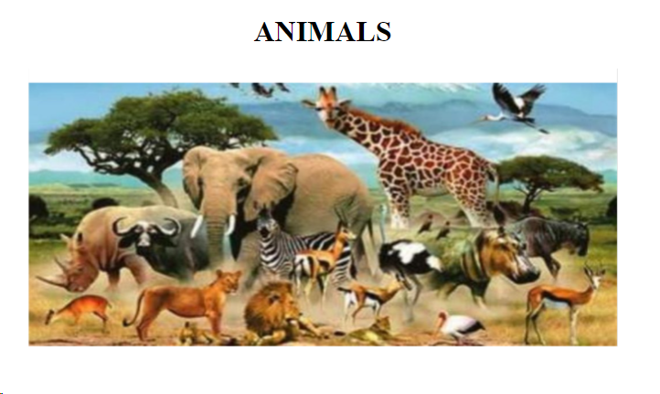

By selection lion picture:

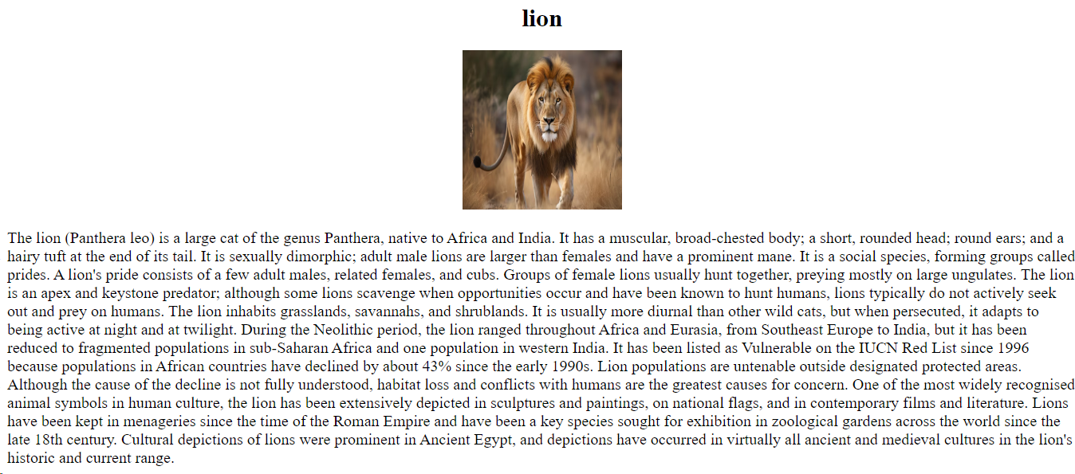

By selection elephant picture:

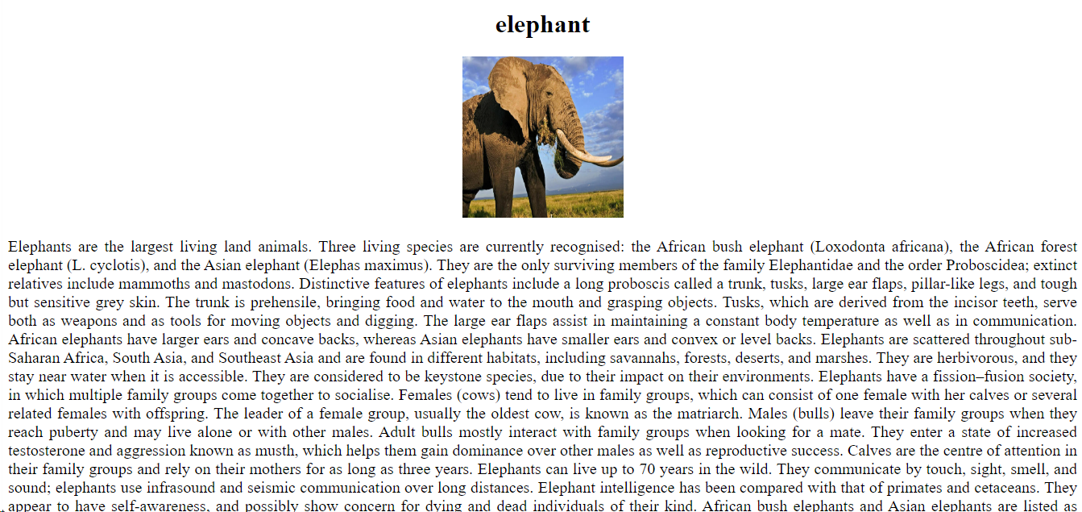

By selection giraffe picture:

